ELECENG 3TP3
Lab 4: Signal Analysis Using Discrete Fourier Transform
Instructor: Dr. Kiruba
Jasmine Dosanjh – dosanj5 – 400531879
Warisha Noushad – noushadw – 400519903
December 19, 2025

Part I: Fast Fourier Transform Analysis

Part 2:
This part of the Lab involves listing to an audio file tones.wav that consists of a signal that is a combination of sinusoidal tones. This audio file plays a constant high-pitched frequency noise for 10 seconds.

Part 3:
The MATLAB code below displays the first 5 ms of the waveform in the file.
Listing 1. Part 3
1. % Read in the signal from the audio file
2. [signal, Fs] = audioread("tones.wav");
3. L = length(signal);
4. T = 1/Fs;
5. t = [0:L-1]*T;
6.
7. % Plot the signal for t_plot msec
8. t_plot = 5;
9. msec_per_sec = 1000;
10. numSamples = t_plot*Fs/msec_per_sec; % takes 5 ms of audio
11.
12. plot(msec_per_sec*t(1:numSamples), signal(1:numSamples))
13. title('Plot of Input Signal');
14. xlabel('Time (ms)');
15. ylabel('Amplitude');
16. grid('minor')
17.
18. % Export the graph
19. text(3.5, 0.56, 'Jasmine Dosanjh - 400531879', 'FontSize', 8)
20. text(3.5, 0.52, 'Warisha Noushad - 400519903', 'FontSize', 8)
21. exportgraphics(gcf, "P1_Q3.jpg")
The generated plot is shown in Figure 1.
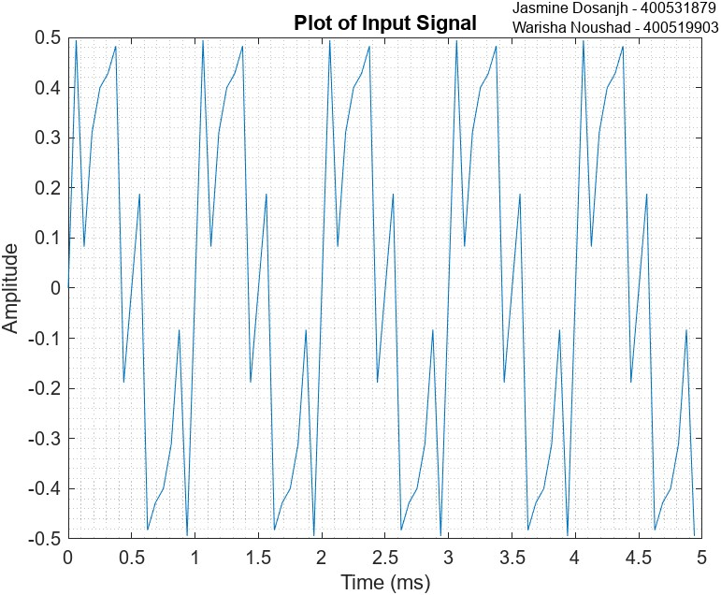
Figure 1. Plot of Input Signal for 5 ms

Part 4:
Based on Figure 1 from Part 3, we can estimate that more than one sinusoid exists, as a single sinusoid should be perfectly smooth, unlike our plot with sharp corners. The waveform is periodic, repeating approximately every 1 ms, thus $T_{0}≈1 ms$. In this duration, 3 peaks occur, implying that there are 3 frequency components. The fundamental frequency is $ω_{0}=1/T_{0}≈1 kHz$. Since every frequency in a periodic signal is an integer multiple $n$ of $ω_{0}$, the 3 sinusoids will have an individual frequency of $n∙ω_{0}$, where $n=n_{1},n_{2},n_{3}$.

Part 5:
Using the fast Fourier transform (FFT), the discrete Fourier transform (DFT) of the audio signal can be found using the code in Listing 2.
Listing 2. Finding DFT of Audio Signal
1. % Read in the signal from the audio file
2. [signal, Fs] = audioread("tones.wav");
3. L = length(signal);
4. T = 1/Fs;
5. t = [0:L-1]*T;
6.
7. % Compute DFT
8. X = fft(signal); % X[k] in default order: | 0 | + | + | + | - | - |
9. X_shift = fftshift(X); % shift to: | - | - | 0 | + | + |
10.
11. % Make the freq x-axis
12. N = length(X); % N integers: -N/2 ... -1 0 1 ... N/2-1
13. k = -N/2 : (N/2)-1;
14. f = (k/N) * Fs; % frequency in Hz
15.
16. % Plot magnitude spectrum
17. stem(f, abs(X_shift))
18. title('Discrete FT of Input Signal');
19. xlabel('Frequency f (Hz)');
20. ylabel('|X(f)|')
21.
22. %Export the graph
23. text(4500, 37000, 'Jasmine Dosanjh - 400531879', 'FontSize', 8)
24. text(4500, 36000, 'Warisha Noushad - 400519903', 'FontSize', 8)
25. exportgraphics(gcf, "P1_Q5.jpg")

The generated stem plots of the magnitude vs frequency of the vectors obtained from the MATLAB fft and fftshift functions are shown in Figure 2.
These functions are related such that fft finds the Discrete Fourier Transform, and fftshift shifts the output so the zero-frequency component is centered, with negative frequencies appearing on the left and positive frequencies on the right.
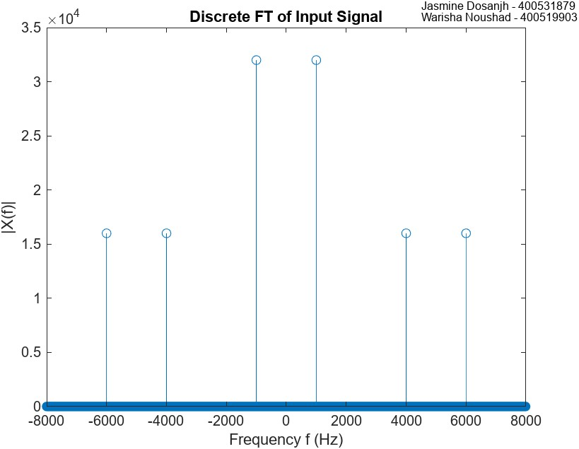
Figure 2. Discrete FT of Input Signal

Part 6:
Figure 3 includes a plot of the single-sided magnitude spectrum of the audio signal. The code in Listing 3 was used to generate this.
Listing 3. Creating Single-Sided Magnitude spectrum
1. % Read in the signal from the audio file
2. [signal, Fs] = audioread("tones.wav");
3. L = length(signal);
4. T = 1/Fs;
5. t = [0:L-1]*T;
6.
7. % Take the DFT
8. Y = fft(signal)/L;
9. f = Fs/2*linspace(0,1,L/2+1);
10.
11. % Plot the single-sided magnitude spectrum.
12. plot(f,2*abs(Y(1:L/2+1)));
13. title('Single-Sided Magnitude Spectrum')
14. xlabel('Frequency (Hz)')
15. ylabel('|Y(f)|')
16. axis([0 Fs/2 0 .5]);
17. grid('minor');
18.
19. % Export the graph
20. text(4500, 0.48, 'Jasmine Dosanjh - 400531879', 'FontSize', 8)
21. text(4500, 0.45, 'Warisha Noushad - 400519903', 'FontSize', 8)
22. exportgraphics(gcf, "P1_Q6.jpg")

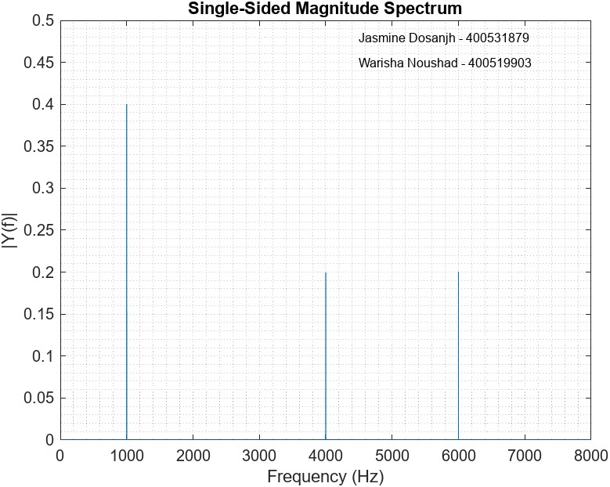
Figure 3. Single-Sided Magnitude Spectrum

Part 7:
Using the results from Part 6, we can see from Figure 3 that the audio signal is made up of three sinusoids.
The frequencies and magnitudes of the sinusoids are:
$$f_{1}=1000 Hz, \left|X(f_{1})\right|=0.4$$
$$f_{2}=4000 Hz, \left|X(f_{2})\right|=0.2$$
$$f_{3}=6000 Hz, \left|X(f_{3})\right|=0.2$$
This corresponds which the hypothesis in Part 4, every sinusoid has a frequency that is an integer multiple $n$ of the fundamental frequency $ω_{0}=1000 Hz$, where $n=n_{1}=1,n_{2}=4,n_{3}=6$.

Part 8:
Using the results from Part 7, Listing 4 shows the MATLAB code used to generate the signal that was used to create the audio file.
Listing 4. Generating Original Audio Signal
1. % Read in the signal from the audio file
2. [signal, Fs] = audioread("tones.wav");
3. L = length(signal);
4. T = 1/Fs;
5. t = [0:L-1]*T;
6.
7. % Recreate og signal
8. signal_1 = 0.4*sin(2*pi*1000*t);
9. signal_2 = 0.2*sin(2*pi*4000*t);
10. signal_3 = 0.2*sin(2*pi*6000*t);
11. combinedSignal = signal_1 + signal_2 + signal_3;
12.
13. % Plot the signal for t_plot msec
14. t_plot = 5;
15. msec_per_sec = 1000;
16. numSamples = t_plot*Fs/msec_per_sec; % takes 5 ms of audio
17.
18. tiledlayout("vertical")
19. x = 0:0.1:5;
20. nexttile;
21. plot(msec_per_sec*t(1:numSamples), signal(1:numSamples))
22. title('Plot of Input Signal'); xlabel('Time (ms)'); ylabel('Amplitude'); grid('minor')
23. nexttile
24. plot(msec_per_sec*t(1:numSamples), combinedSignal(1:numSamples))
25. title('Reconstructed Signal'); xlabel('Time (ms)'); ylabel('Amplitude'); grid('minor')
26.
27. % Export the graph
28. text(3.5, 0.6, 'Jasmine Dosanjh - 400531879', 'FontSize', 8)
29. text(3.5, 0.7, 'Warisha Noushad - 400519903', 'FontSize', 8)
30. exportgraphics(gcf, "P1_Q8.jpg")

The first 5 ms of the reconstructed signal are plotted, so that it can be compared to the original signal found in Part 3. There are no differences, the signals are identical.
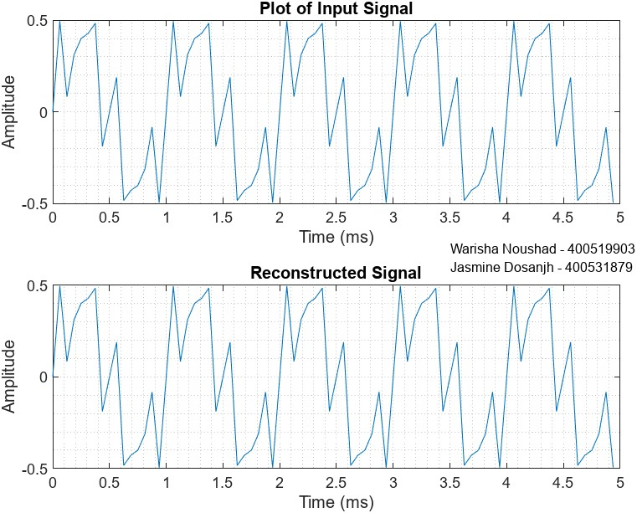
Figure 4. Reconstructed Signal vs Original Signal

Part 2: Decoding Secret Message

Part 2:
A high-pitched static noise with constant ringing in the background.

Part 3:
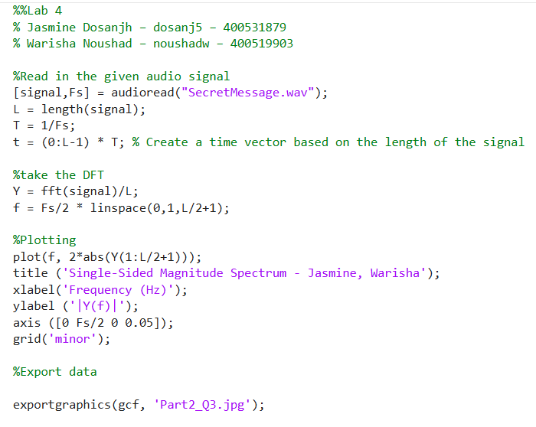

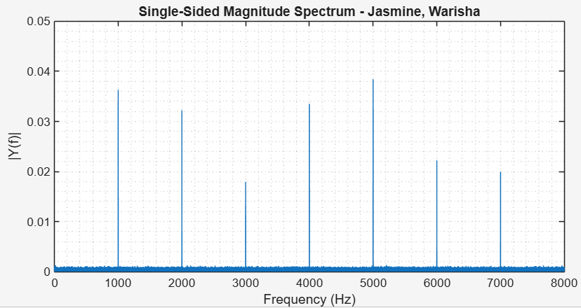

Part 4:
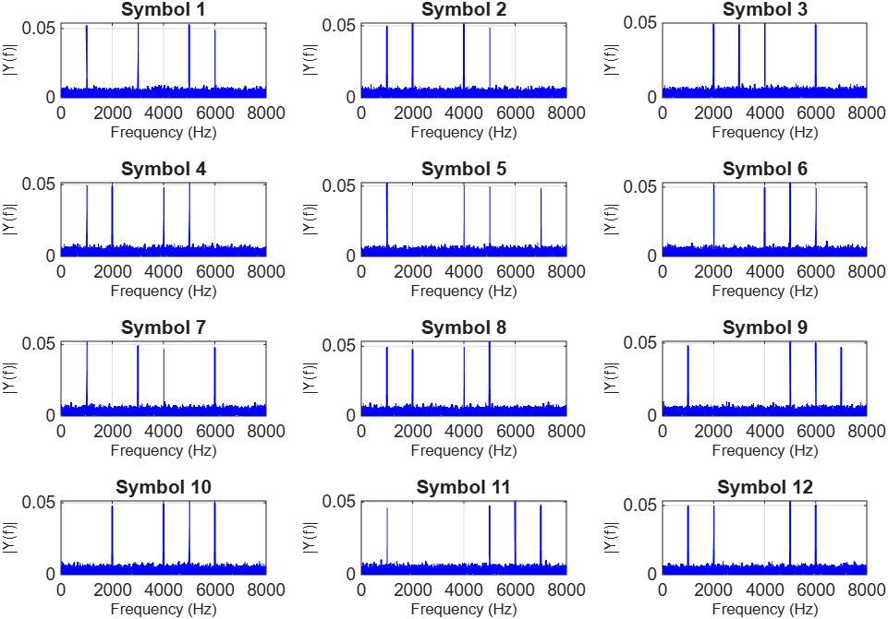
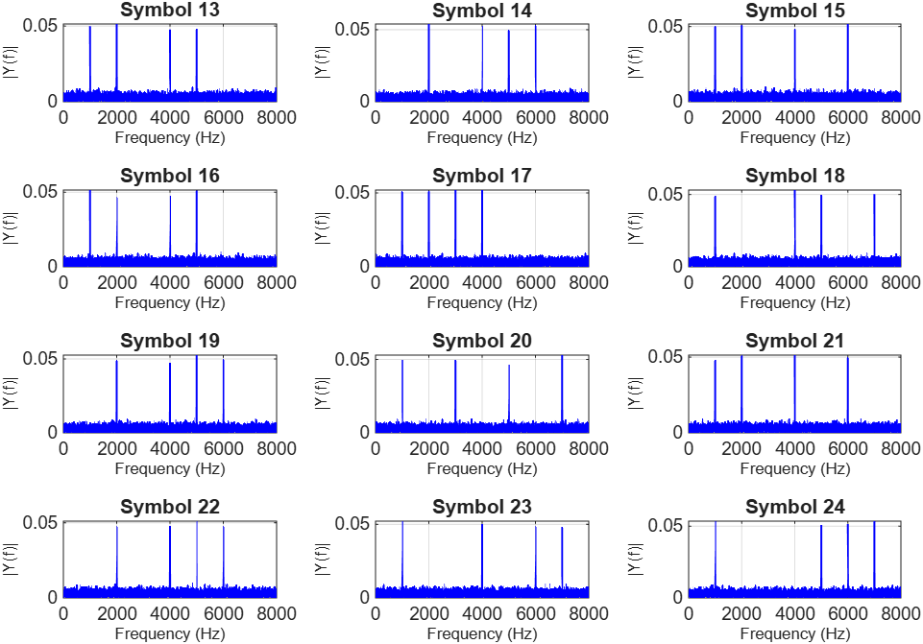
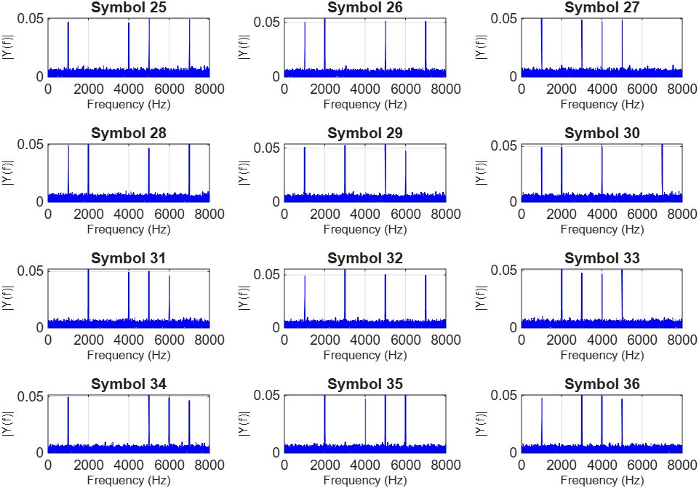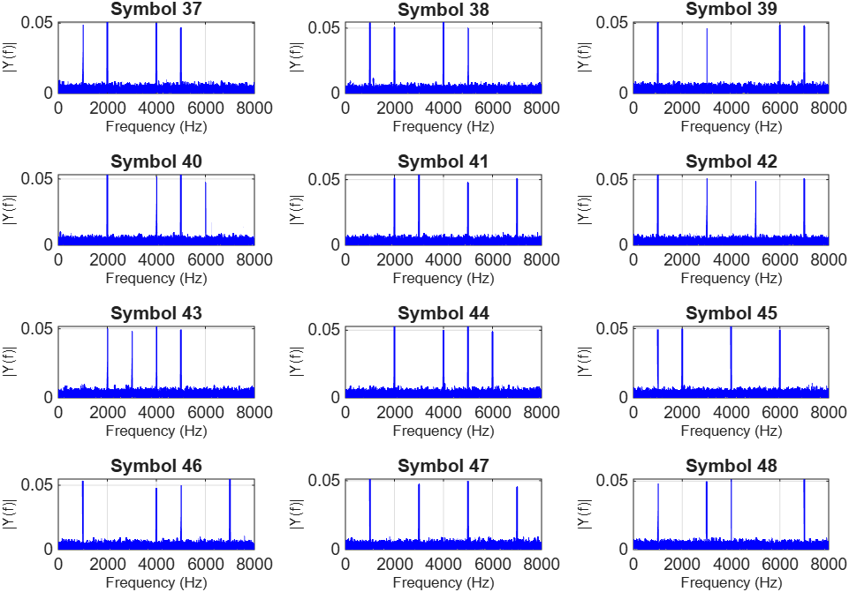
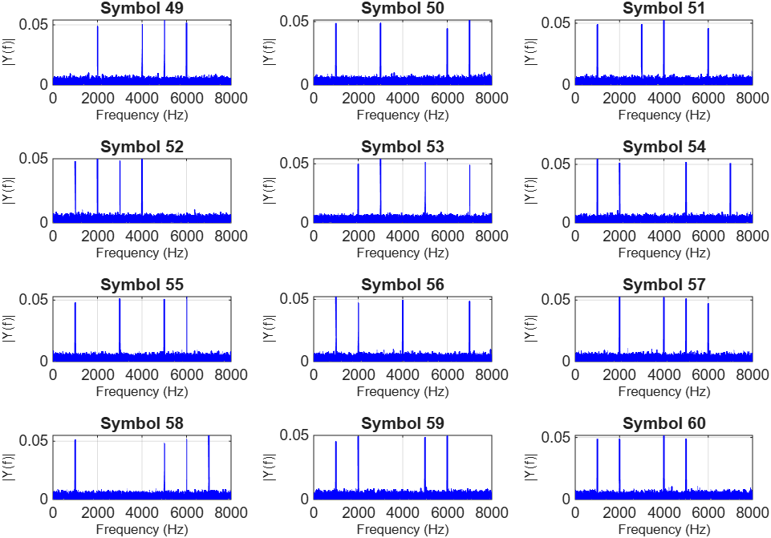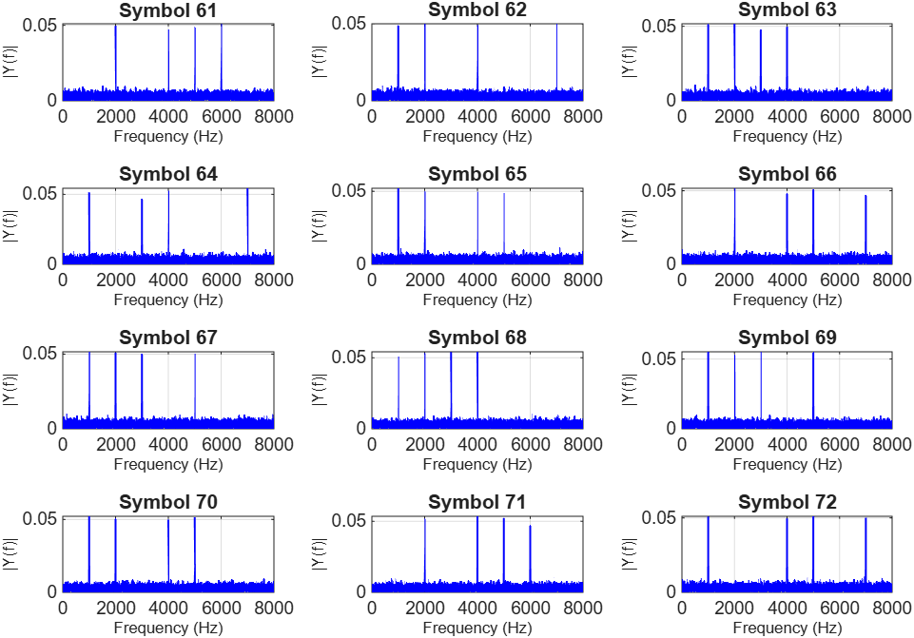
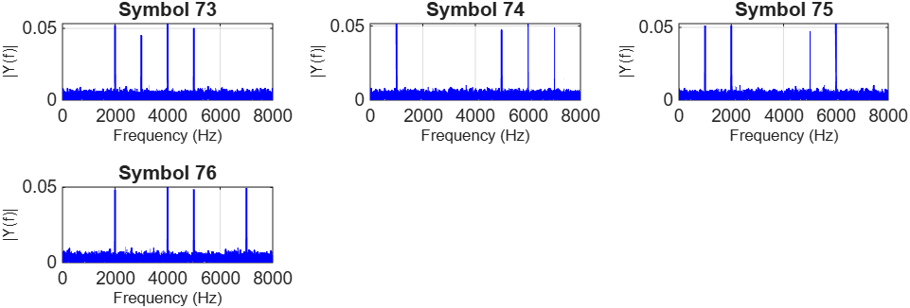

The decoded message is:
“NEVER LET THE FEAR OF STRIKING OUT KEEP YOU FROM PLAYING THE GAME.BABE RUTH.”

